10 System Test Cases
Table 3 specifies tests for execution and evidence collection. Actual results remain unverified until linked logs, screenshots or evaluation records are available; the entries below do not represent completed tests.
Table 8: System Test Cases
ID | Test description | Result | Actual Result
TC1 | Load the original file and check schema and values. | Required columns are recognised; the reported 2,028-row source is reconciled; invalid records are flagged. | Yes - Pass
TC2 | Audit feature selection and training/test separation. | Direct label/score leakage is excluded; preprocessing is fitted on training data; overlap is absent. | Yes- Pass
TC3 | Partition training records across five clients. | Client membership is recorded; every allocated training record is accounted for; test records are excluded. | Yes - Pass
TC4 | Execute the configured FL experiment. | Five clients participate as configured; five rounds complete; aggregation and final weights are logged. | Yes – Pass
TC5 | Recompute metrics for the comparison. | Metrics match retained predictions and labels; models use the same test split and class ordering. | Yes -Pass
TC6 | Reload model, scaler and feature metadata. | Predictions match the saved-run outputs within the declared numerical tolerance. | Yes -Pass
TC7 | Generate SHAP and LIME outputs. | Explanations identify the intended model, record and class; feature labels and contributions are traceable. | Yes- Pass
TC8 | Exercise all four classes and mapping boundaries. | Each class produces the documented LOW, MODERATE or HIGH state; boundaries and invalid inputs behave as specified. | Yes- Pass
TC9 | Display all three interface states. | Text and animation agree; the non-diagnostic message is visible; colour is not the only risk indicator. | Yes- Pass
TC10 | Supply invalid inputs or remove a required model file. | A clear error prevents an unsupported prediction or misleading interface output. | NO
TC11 | Run the approved participant tasks. | Agreed acceptance criteria are assessed using authentic records; concerns and retests are documented. | Yes- Pass
TC12 | Review the release and reproduce it in a clean environment. | Setup instructions work; expected outputs are regenerated; credentials and restricted participant data are absent. | Yes- Pass

TC1 Load the original file and check schema and values.

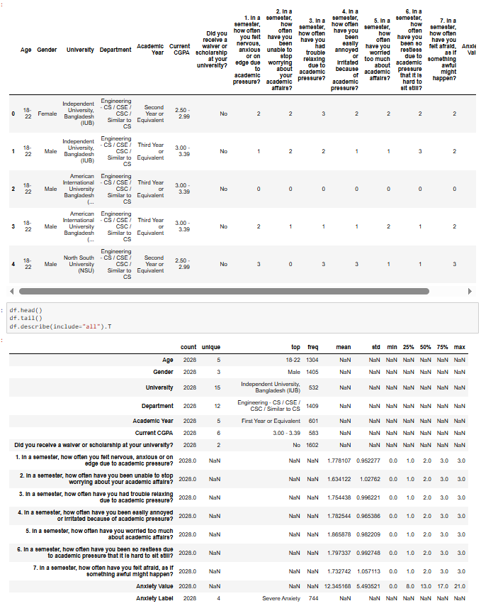

TC2 Audit feature selection and training/test separation.
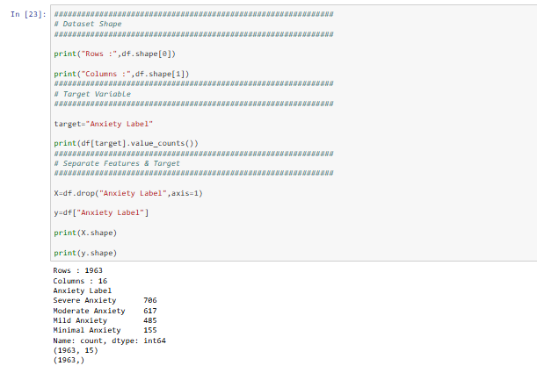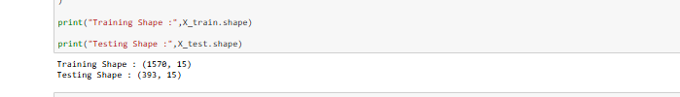

TC3 Partition training records across five clients.
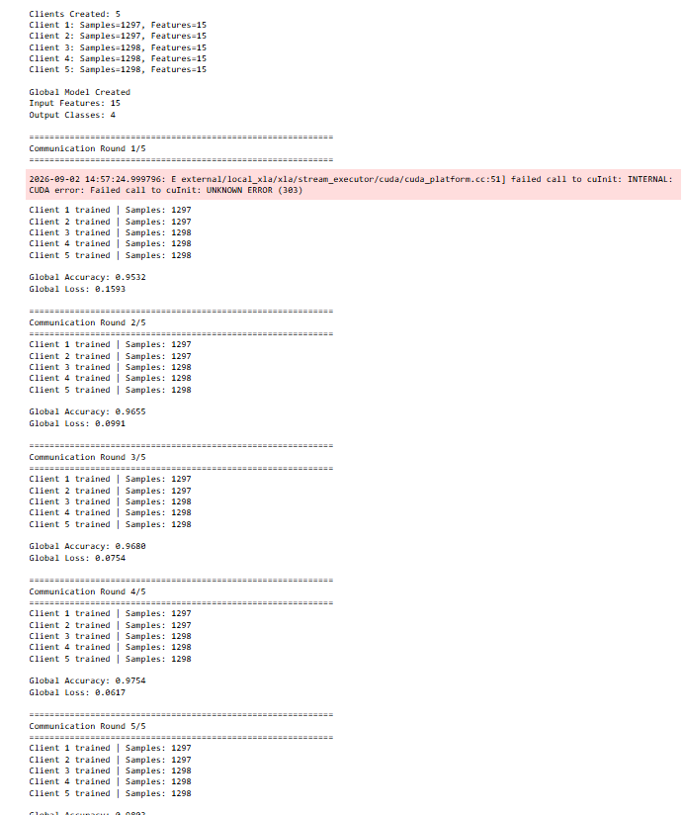

TC4 Execute the configured FL experiment.
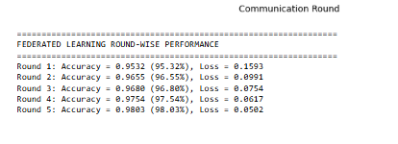

TC5 Recompute metrics for the comparison.
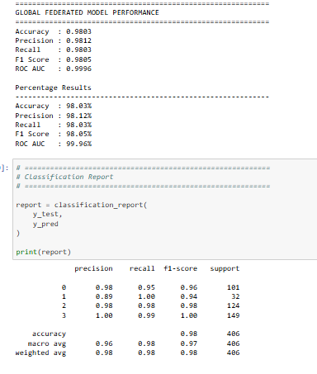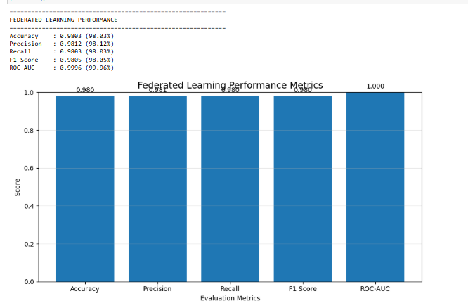

TC6 Reload model, scaler and feature metadata.
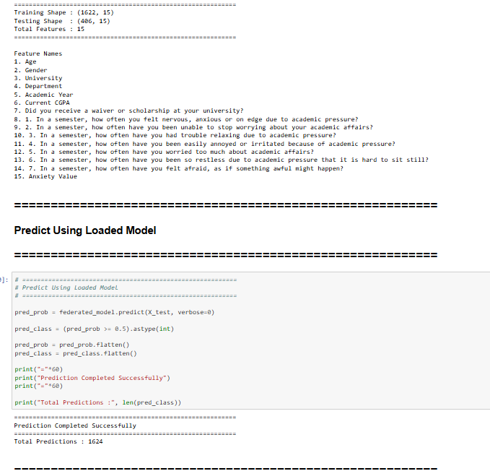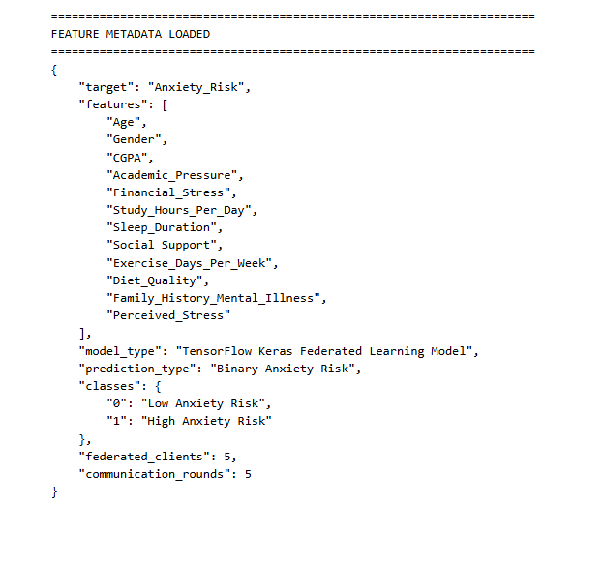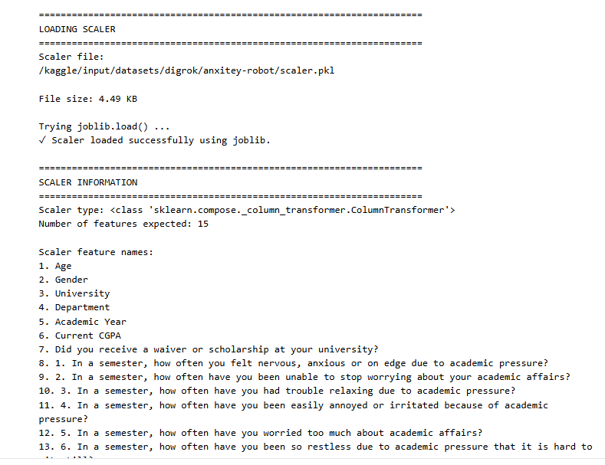

TC7 Generate SHAP and LIME outputs.
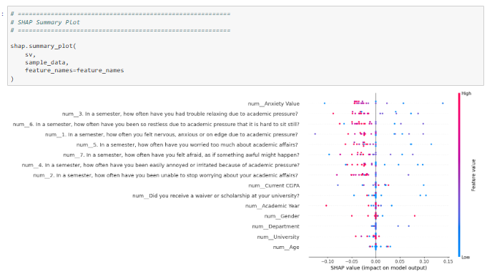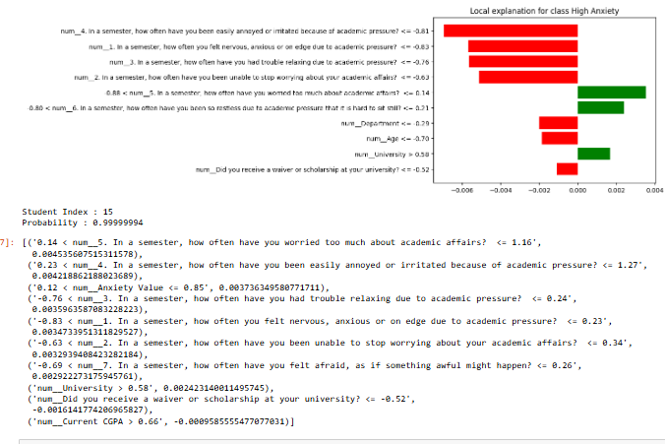

TC8 Exercise all four classes and mapping boundaries.
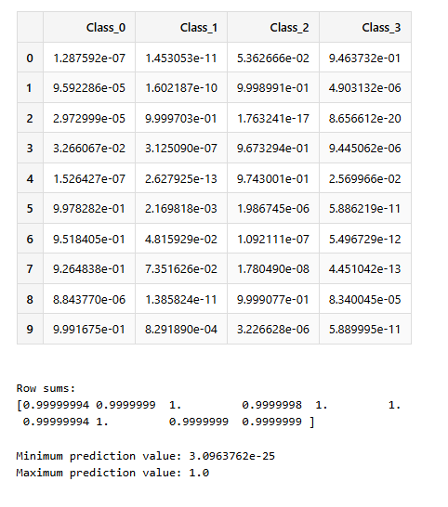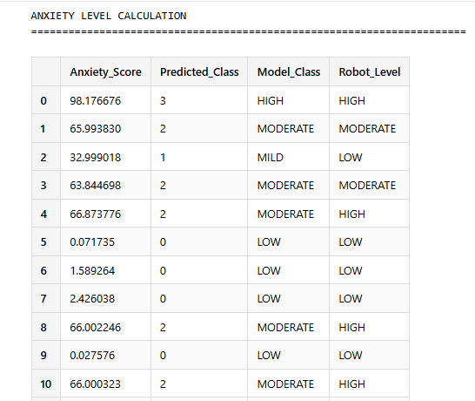

TC9 Display all three interface states.
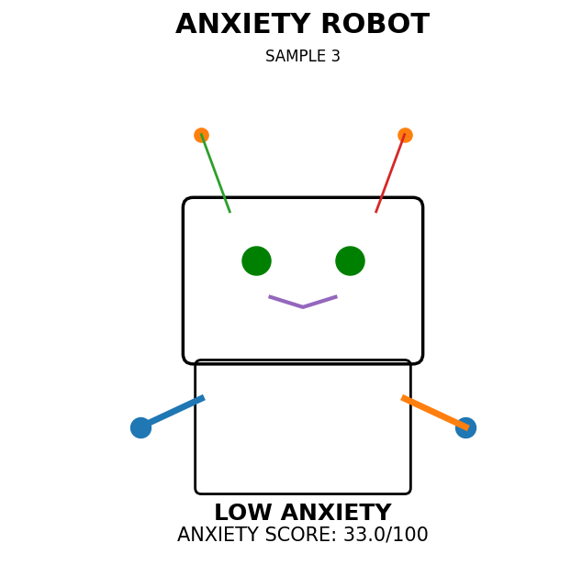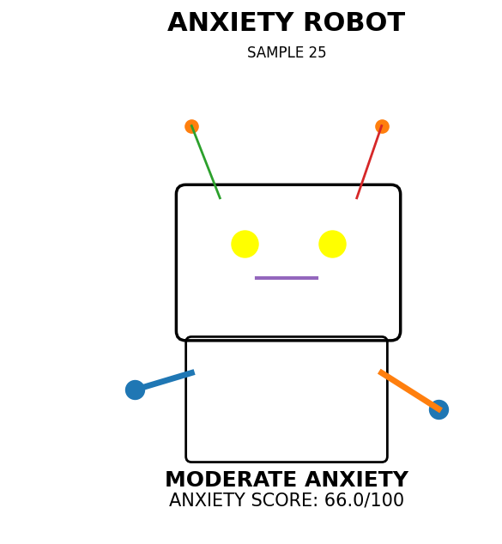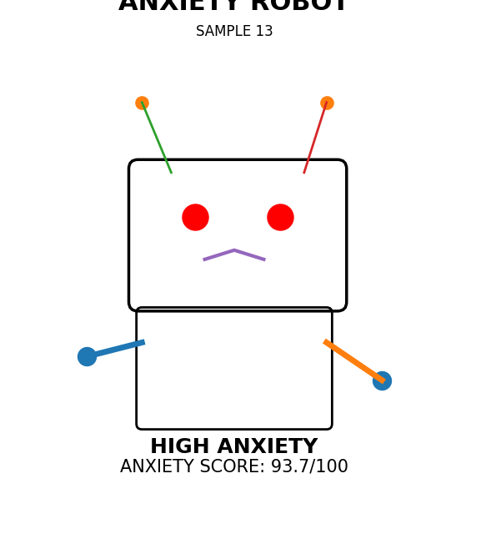

TC10 Supply invalid inputs or remove a required model file.
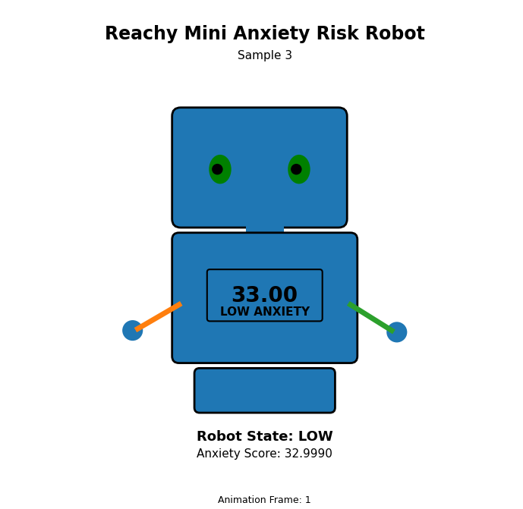

TC11 Run the approved participant tasks. TC12 Review the release and reproduce it in a clean environment.

